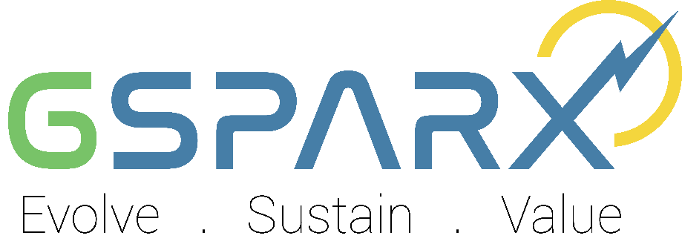

ADDITIONAL INFORMATION

COMPANY NAME

Aras 31, PJX HM Shah Tower, Persiaran Barat,
46050 Petaling Jaya, Selangor Darul Ehsan

ISI KANDUNGAN
VOLUME 2

KANDUNGAN | MUKA SURAT
DOCUMENT TITLE | 1
TABLE OF CONTENT | 2
FORM A : COMPANY PROFILE ( ADDITIONAL ) | 3
FORM B : LIST OF EXPERIENCE | 4
FORM C : GSPARX INTEGRITY PACT | 5
FORM D : LIGITATION DECLARATION FORM | 6
FORM E : PRICE SCHEDULE | 7-8
FORM F : DOCUMENT CHECKLIST & COMPANY DECLARATION | 9-10
* Note: Please use company’s stamp and each initial each pages by applicant

Applicant must fill-up completely the form given . Failure to do to so might result to rejection to the offer given.

FORM A
PROFAIL PETENDER

COMPANY NAME :
1 | Shareholders | No | Shareholder Name |  | Equity Percentage (%)
 |  | 1
 |  | 2
 |  | 3
 |  | 4
2 | Board of Director | No | Board of Director Name
 |  | 1
 |  | 2
 |  | 3
 |  | 4
3 | Key Personnel’s | Designation |  | Employee Name
 |  | Managing Director
 |  | Director
 |  | General Manager (Finance)
General Manager
(Corporate/Support Service)
 |  | Manager
4 | Composition of Workforce in main business | Management / Profesional |  | No
 |  | - Citizen
 |  | - Expatriate
 |  | Work Force |  | No
 |  | - Citizen
 |  | - Expatriate
5 | No. of PV Project | Completed |  | Construction
FORM B

LIST OF APPLICANT EXPERIENCE

Solar PV Power Project
No. | Item | Project 1 | Project 2 | Project 3
1 | Name of Plant
2 | Location of Plant
3 | Name of Project Company
4 | Name of Developer(s)
5 | Inverter Technology - Central / String
6 | Status of Plant
7 | Value of Contract
8 | Principal Manufactures of Major Equipment
9 | Other Details:  Duration of Construction Period  Commercial Operation Date of Units
Tenderer to produce additional sheets as necessary.

FORM C

GSPARX INTEGRITY PACT

We acknowledge the commitment of GSPARX Sdn. Bhd. (GSPARX), to ethical business, and hereby undertake to act with integrity in all our dealings with GSPARX. We express our commitment by undertaking the following: -
- We shall perform all contractual obligations professionally and ethically;
- We shall comply with GSPARX’s code of business conduct & ethics and applicable policies, procedures and guidelines at all times;
- We shall not conspire or collude with other companies;
- We shall not disclose details of the tender/contract to any party without prior written consent from the Procurement Department of GSPARX;
- If any products or part thereof are procured from a third party, we shall not present such products as our own without disclosing the third party;
- We shall not give, offer or promise any kind of bribe, reward or other form of ‘gratification’ (as defined in Section 3 of the Malaysian Anti-Corruption Commission Act 2009) to an employee, agent, director or other representative of GSPARX in relation to this or any other tender/contract with GSPARX, at any stage of the tender/contract;
- We shall expeditiously report to the Malaysian Anti-Corruption Commission and/or to a senior officer of GSPARX if an employee, agent or director of GSPARX requests for any form of gratification at any stage of the tender/contract; and
- We shall inform and ensure that our employees, agents, directors, and other representatives of our company comply with these requirements.

If we are found to be in breach of the above, or to have undertaken any other unlawful or illegal activities in relation to this tender/contract, we agree that the following actions shall be taken:
- GSPARX shall immediately terminate the tender/contract without any cost, penalty or liability to GSPARX; and/or
- Our company and its directors shall be blacklisted from participating in GSPARX’s future procurement activity; and/or
- We shall indemnify GSPARX, its officers, employees, servants and agents against any claims, losses or damages arising from such breach or from such unlawful or illegal activities.

On behalf of the company:

 |  |  | NRIC/Passport No. | : | ........................................
Signature | : | ........................................ | Position | : | ........................................
Name | : | ........................................ | Company Stamp | :

FORM D

LITIGATION DECLARATION FORM

Company Letterhead

SURAT AKUAN SUMPAH

Dengan ini saya mewakili syarikat, _________________________(Co. No: ___________)
dan beralamat di __________________________________________________________________________________________________________________________________________________
dengan sesungguh dan sebenarnya mengaku bahawa tiada sebarang kes litigasi atau tindakan mahkamah yang berkaitan dengan Tenaga Nasional Berhad (TNB) atau anak syarikatnya. Dan saya membuat akuan ini dengan kepercayaan bahawa apa-apa yang tersebut di dalamnya adalah benar, serta menurut Akta Akuan Berkanun 1960.

Diakui oleh yang tersebut namanya di atas;

Diperbuat dengan sebenar-benarnya: |  |  | Diakui oleh yang tersebut namanya di atas;
Nama | : | …………………………………...)
Jawatan | : | …………………………………...)
Di | : | …………………………………...) | …………………………………..
Negeri |  | …………………………………...) | (Tandatangan ,Nama & IC)
Pada |  | …………………………………...) | Cop Syarikat:

Di hadapan saya,

……………………………………………………..
Tandatangan Pesuruhjaya Sumpah
(Nama & Cop)

FORM E

PRICE SCHEDULE

DEVELOPMENT OF SELF - CONSUMPTION / SELF – GENERATION PROJECT
No | Residential Package | Scope 1 (Installers) (RM/kWp) | Scope 2  (Full EPCC) (RM/kWp) | O&M  (RM/Yearly)
1 | 2kWp
2 | 3kWp
3 | 4kWp
4 | 5kWp
5 | 6kWp
6 | 8kWp
7 | 10kWp
8 | 12kWp

 | No | System Size for Commercial & Industry |  |  | Scope 1 (Installers)  (RM/kWp) |  | Scope 2  (Full EPCC)  (RM/kWp) |  | NEMAS / PSS per Installation |  | O&M (RM/Yearly)
 | 1 | Below 50kWp
 | 2 | 50kWp
 | 3 | 100kWp
 | 4 | 200kWp
 | 5 | 300kWp
 | 6 | 400kWp
 | 7 | 500kWp
 | 8 | 600kWp
 | 9 | 700kWp
 | 10 | 800kWp
 | 11 | 900kWp
 | 12 | 1,000kWp
 | 13 | 2,000kWp
 | 14 | 3,000kWp
 | 11 | 4,000kWp
 | 12 | 5,000kWp
 | 13 | 10,000kWp
 | 14 | More than 10,000kWp
Note: The rate shall be applicable for any system size above the indicated system size. Eg. Rate specified in 50kWp row shall be applicable up to the next row, 100kWp.

I hereby confirm that all of the above particulars are true:

Signature
Name
Designation
Date |  |  |  |  |  |  |  | (Company Seal)

FORM F

DOCUMENT CHECKLIST

Please verify and tick (√) for any required document attached or (X) for any required document which not attach , at the field provided in the table below .

NO | MANDATORY DOCUMENT | Attach  (√) atau (X)
 | Form A : Applicant Profile (Additional)
Form B: List of Company Experience
Experience in implementing related works not more than one (1) contract within lastest five (5) years .
Contract/sub contract offer letter / Taking Over Certificate (TOC) / Completion Certificate (CC) / Agreement / Purchased Order (PO)
 | Form C: GSPARX Integrity Pact Form.
 | Form D: Litigation Declaration Form
 | Form E: Price Schedule
 | Form F: Document Checklist.
 | Copy Sijil SSM, SEDA, EC dan CIDB
Copy of Personnel
- GCPV Certificate
- Chargemen / Wiremen Certificate
- CV
 | Latest 3 years Audited Financial Statement.
Document that support Acid Test Ratio criteria as follows :
- Current Asset, Stock & Current Liabilities.
- Unutilized revolving credit facilities.
 | The average latest 3 months bank balance statement.

FORM F (Cont)

Important Note :

  - Summited a copy of latest company registration certificate which still valid within (one) 1 years after the submission of this application .

  - If we found that document submitted were not complete , GSPARX has the right to reject the application .

  - All required DOCUMENTS and COMPLETE FORM were required to upload in this application:

I hereby confirm that all the above mandatory documents have been included in this application document . I also note that failure such mandatory documents will result in the offer being rejected .

Company : ................................................... Siganture & Cop
Name

Date : ...................................................

No. Tel/ No. Fax : ................................................... ................................................

*This declaration must be signed by the Managing Director or Chief Execvutive Officer of the company.

